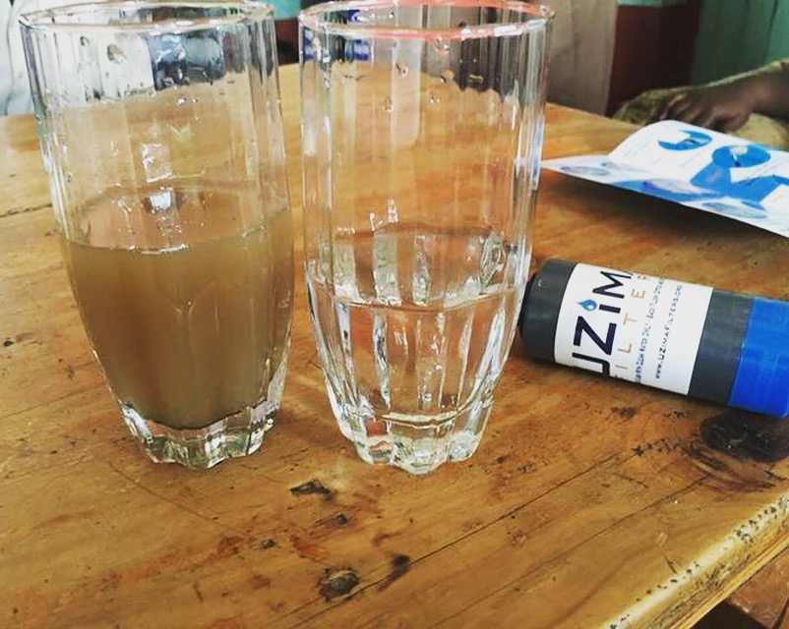
PRUMC Kenya Mission Team Handbook
April 27-May 7 2023
Team Leader: Clint Smith
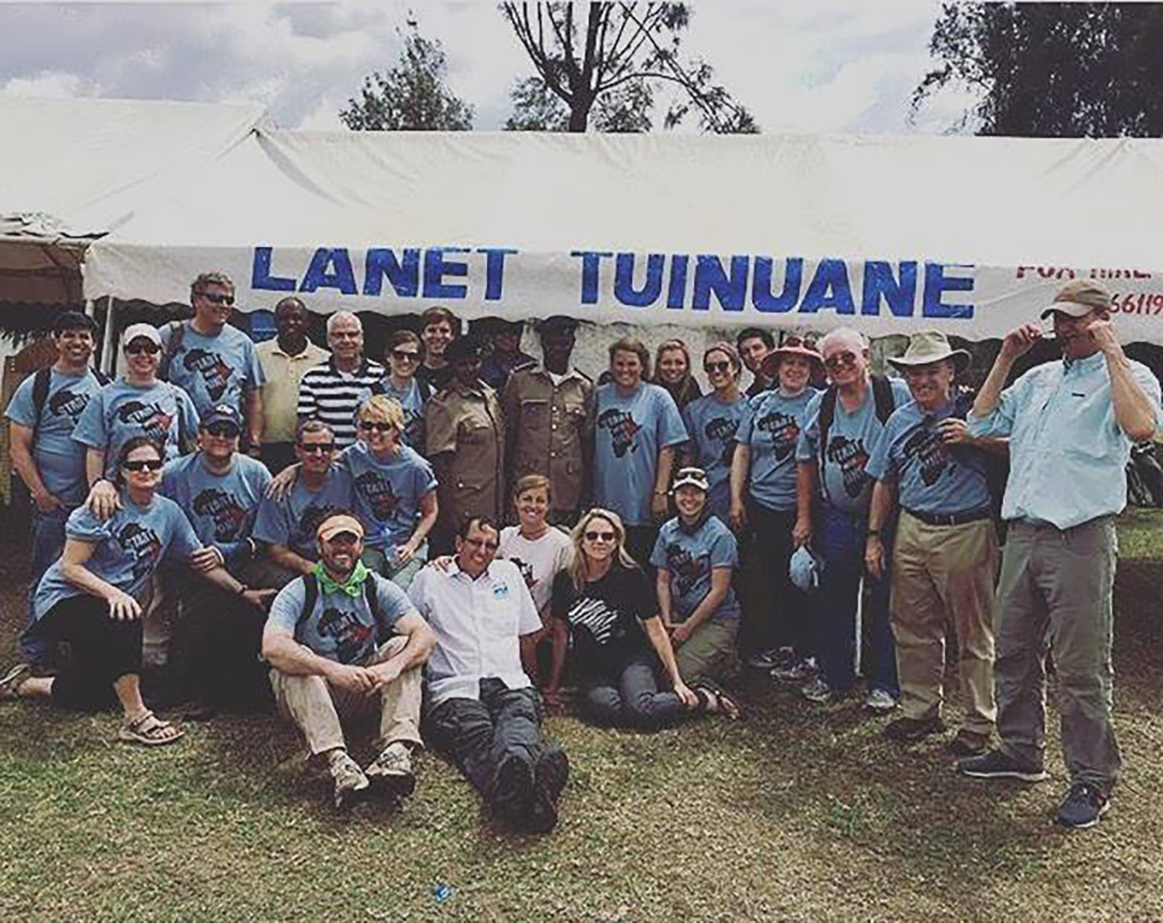

Purpose:
We hope this handbook can be used as a tool to help you prepare for your journey to Kenya and to give you a better understanding of what to expect while you are there.

Table of Contents:

Topic | Page
Team Roster | 4
Kenya Mission Team & Our Missionaries | 5
Accommodations | 6
Itinerary & Cost | 7
Travel Documents | 8
Money Matters | 9
Insurance | 10
Packing List | 11
Packing Tips | 12
Food Basics | 14
Safety Tips | 15
Airport Information | 16
Medical Information | 17
Immunizations | 18
Preparing Our Hearts for Service | 20
10 commandments for mission teams | 21
Flexibility/ Basic Swahili Phrases | 22
Kenya 101: General Information | 23
Values and Attitudes | 29
The People of Kenya | 30
Religions & Beliefs | 33

Team Roster

 | First Name | Last Name
 | Clint | Smith
 | Becky | Maas
 | Julie | Wright
 | Kyle | Jenks
 | Chris | Revell
 | Ed | Hamlin

Our Kenya Partners

Start with One - Kenya: Bill & Chat Coble are the founders of the organization which provides opportunities for people to make a significant and sustainable difference in the world through their support and active participation. www.StartWithOneKenya.org

- Bill Coble
404-402-2832 (US); 011-254-72-1590123 (Kenya)
bill@startwithonekenya.org
Address: P.O. Box 18266-20100, Nakuru, Kenya
- Chat Coble
404-395-0470 (US)
ukenchat@gmail.com

Flights:

Thu, 27APR | DEPART | ARRIVE
DELTA 8672*  Economy (X) | ATLANTA  8:05pm | PARIS-DEGAULLE  10:20am  **Fri 28APR
Fri, 28APR | DEPART | ARRIVE
DELTA 8681*  Economy (X) | PARIS-DEGAULLE  12:15pm | NAIROBI, KENYA  9:20pm
Sat, 06MAY | DEPART | ARRIVE
DELTA 9596*  Europe Economy (K) | NAIROBI, KENYA  11:59pm | AMSTERDAM, NETHERLANDS  7:15am  **Sun 07MAY
Sun, 07MAY | DEPART | ARRIVE
DELTA 73  Main Cabin (K) | AMSTERDAM, NETHERLANDS  10:35am | ATLANTA  2:20pm

Accommodations

Crowne Plaza - Nairobi Airport
We are staying within the airport grounds as routine safety precaution.
First Freight Lane, Jomo Kenyatta International Airport, Nairobi, Kenya 37813-0100
+254.719.017000

Presbyterian motel – Tumaini Conference Centre
www.tumainiconferencecenter.org
PO Box 7120, Rift Valley/Nakuru, Kenya 20100
Phone Number: 254.020.219.5971 and 254.720.311525
Used as a motel retreat center in Nakuru. 3 hour ride from Nairobi. Comfortable and firm beds, clean rooms, mosquito nets over beds – please use every night
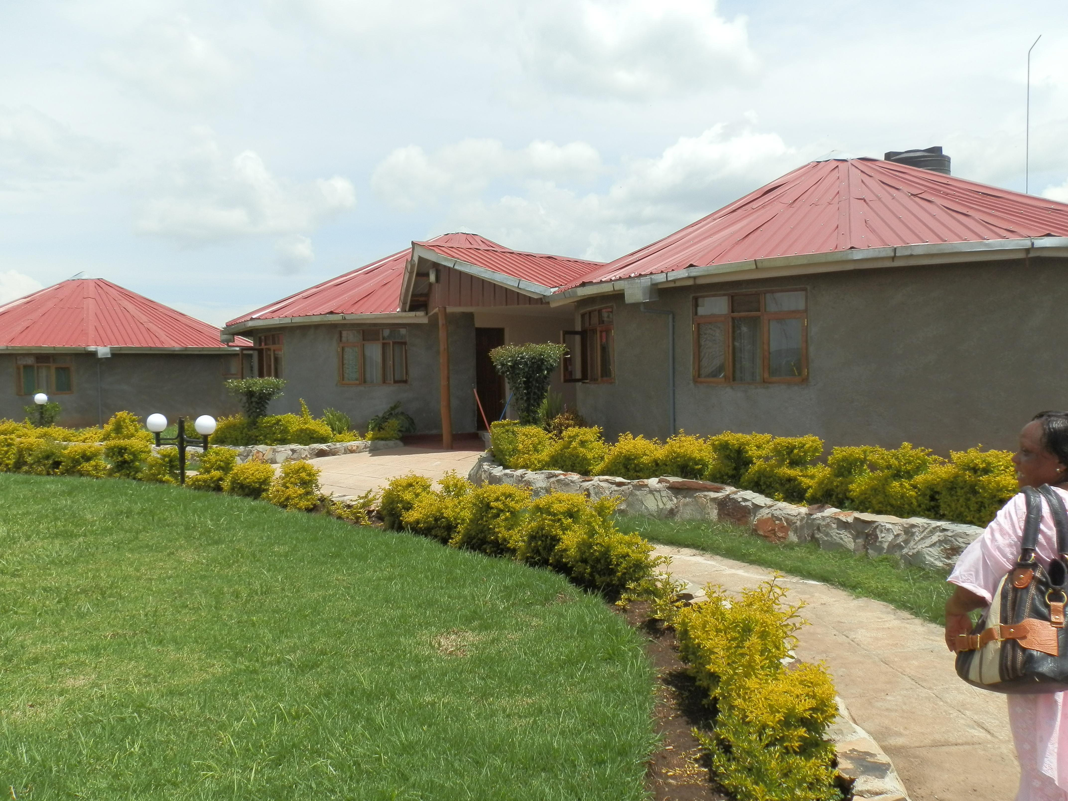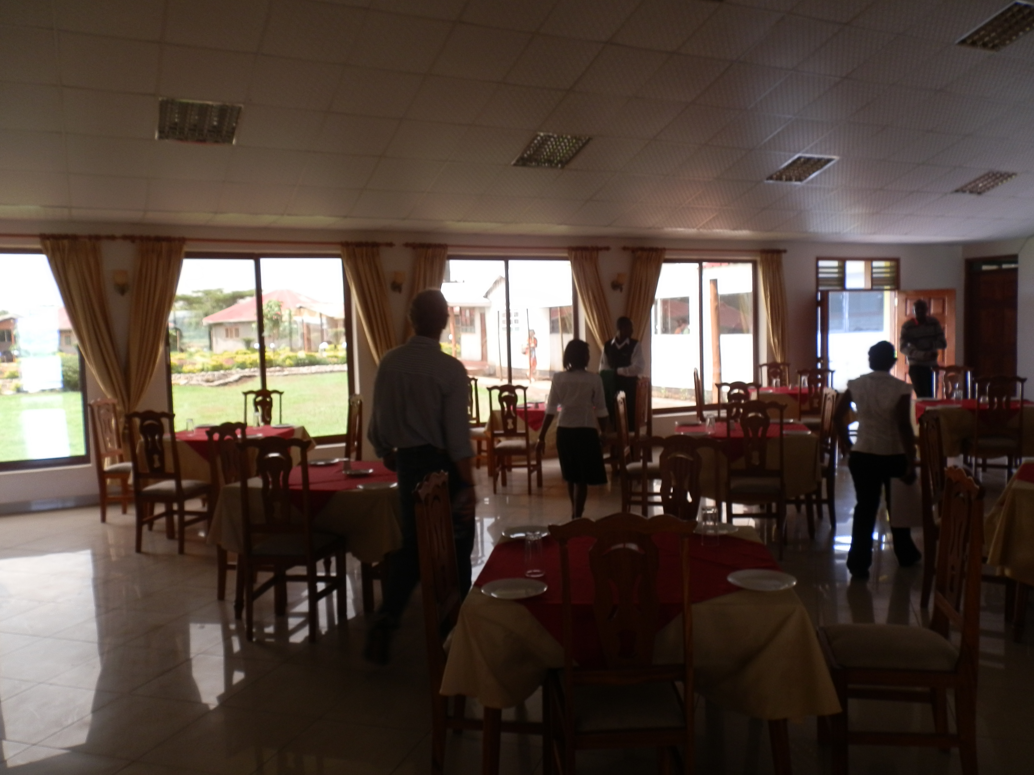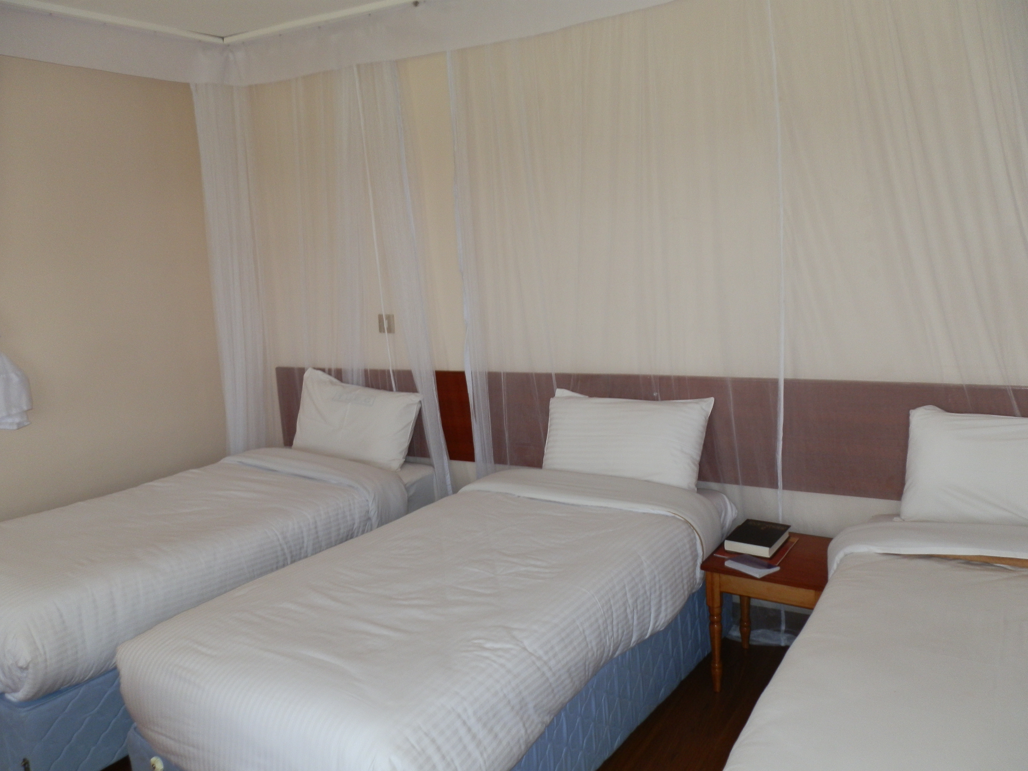

Tentative Itinerary

Thursday | April 27, 2023 | Evening departure (approx 24 hours of travel time)
Friday | April 28, 2023 | Evening arrival in Nairobi, Kenya. Overnight in Nairobi.
Saturday | April 29, 2023 | Potential -- work at Deep Sea.  Travel to Nakuru area.
Sunday | April 30, 2023 | Morning worship service Afternoon mission projects TBD
Mon-Fri | May 1-5, 2023 | Mission projects in the Nakuru area. Water filter distribution, construction, and children’s activities.
Saturday | May 6, 2023 | Travel from Nakuru to Nairobi Evening departure flight from Nairobi
Sunday | May 27, 2023 | Afternoon arrival in Atlanta

Cost

$2750, includes airfare, room & board
Make payment to PRUMC and deliver to Dawn or Pay via ServiceReef donation
Cash for Incidentals, souvenirs, etc. – approximately $150-$200

Travel Documents / Department of State

Passports:
Important that your passport will not expire before 6 months after our return from Kenya. Also important to have at least 3 blank pages left in your passport.

Kenyan Visa:
-Go to www.evisa.go.ke *It is very important not to Google “Kenyan Visa” to get to site.*
-Create an account (or Sign In to an existing account)
-Once you have completed making a profile (or logged on) you will click “Get service now”
-Then click “make an application.”
-You will need to upload a copy of your current passport, along with another passport sized picture.
-The cost will be $51.00
-Do NOT mail in your passport.
-For any questions about this process please contact Anne at annef@prumc.org or Clint at clintonw.smith@gmail.com

Registering with the U.S. DEPARTMENT of STATE:
It is a good idea to let the U.S. Government (U.S. Department of State) know of your whereabouts when we travel internationally, especially to remote countries. Please register on the U.S. Department of State ‘Smart Traveler Enrollment Program (STEP)’ site prior to departure.
- Register on-line: https://travelregistration.state.gov/ibrs/ui/
- Create an individual account
- Under “Itinerary” use the following Destination Address:
Tumaini Conference Center
Nakuru, Kenya
- Use the following Destination Phone #:
254-72-1590123

Stay informed on U.S. Department of State Travel Warnings & Travel Alerts:
The U.S. Government keeps a current list of travel warnings and travel alerts by each country. Read each travel warning in light of the specific place in Kenya you will be traveling (i.e., Nairobi, Nakuru). If you have any questions or want to discuss please give me a call.

http://travel.state.gov

Money Matters

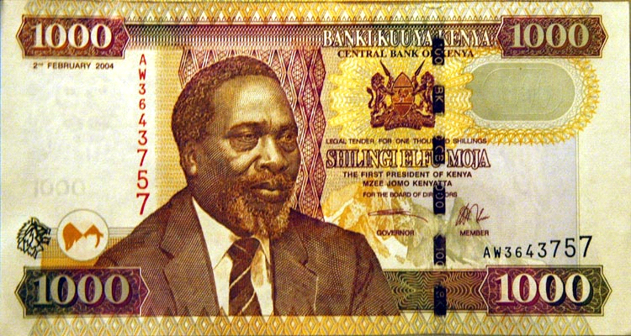
The Kenyan currency is the Kenyan Shilling. Exchange rates vary but typically $1 US yields around 100 Kenyan Shillings.
There are a couple of opportunities to exchange money – including at the airport. Chat and Bill may also offer to be our “banker” and exchange any amounts of money that we need.
Some more sophisticated merchants will take credit cards. Other more local vendors will take Kenya Shillings.
Bring crisp, new U.S. bills in $100’s and $50’s. Should be 2003 or newer. Older bills get less of an exchange rate and many places will not take a bill older than 2003 or in smaller denominations. Start with One will be able to change your US bill to Kenya shillings
Costs that you will need to cover on your own:
- Food in route to Kenya (i.e., in airports)
- Meals in Nairobi (on arrival and departure day)
- Extra snacks and drinks you purchase at the Kenya grocery
- Your beverage tab at the motel
- Laundry washing fees
- Shopping / gifts of kindness donations
How much to bring? It depends on how much of a shopper you are! However, prices are very affordable so I would say in the range of $100-$500.
The Kenyans like to haggle on the prices so never accept the initial price offered! Also, I recommend bringing a small solar calculator to help you translate the prices quickly.
Insurance
The church purchases the following insurance for each team member:
- Accident Coverage AND Medical Coverage.
- Limit of $25,000 - includes both accident and illness after $50 deductible
- Includes a pre-existing condition waiver of up to $15,000
- Medical Evacuation/Repatriation: $100,000
- Trip Interruption coverage: included up to $5,000. The covered person will be returned home if there is the death of an immediate family member, or serious damage to the insured's principal dwelling
- Lost luggage: up to $250
- Emergency Medical Reunion: included for one person in case of Medical Evacuation or Repatriation
Here is a link to more specifics on the UMVIM website:
http://umvim.org/resources/insurance-faq/
The insurance the church purchases for us will not cover trip cancelations. This is something you can purchase additionally. Basically, if you need to cancel from the trip, it would be the cost of the plane ticket that you would have …. and you would need to negotiate with Delta if you can reuse part of the ticket for a future trip.
Additional / Optional Insurance (for trip cancellations & increased medical coverage)
Dr. Bob recommends using the following vendor: http://insuremytrip.com

Packing List

Must Have | Nice to Have
Anti-Bacterial Soap/Handwipes/Gel | Advil
Backpack / Day pack | Downey Sheets
Bible | Alarm clock
Camera (batteries / charger) | *Bandanna (good for dust)
Cash (new bills, higher denominations) | Binoculars (safari)
Church Clothes (dress/skirt that hits below the knee) | Calculator
Credit Card (call credit co. to tell them your travels) | Contact lens cleaner
Flashlight (batteries) | *Crystal Light/Gatorade (or other flavor packets)
Food (for your own snacks) | Detergent (small amount to wash clothes in the sink)
Hat (with a brim) | *Devotional Materials / Journal
Immunization Record (Yellow card) | *Ear Plugs
Jacket (light weight)/Raincoat | *Eye Shades
Kenya Team Handbook | Games/Cards
Kleenex | *iPod and earphones
Malarial Medication | Laptop / iPad
Moisturizer | Polysporin
Nose spray (optional) | Reading Materials
Passport (and copy of passport and credit cards) | *Work Site Goggles
Pepto Bismal & Cypro | *Wash cloths
Prescription Medication | Travel pillow
Shoes/Boots (closed-toe) waterproof or tennis shoes | Wallet
Soap/Shampoo | Watch
Socks
Sunglasses
Sunscreen
Toilet Paper (one partial roll) (optional)
Toiletries
Towelletes / Hand wipes
Underwear/Sleepwear
Work Clothes- long pants (no shorts - cultural), short/long sleeve shirts (that cover the shoulder)
*Work Gloves
*Water Bottle – Must Have!
*New Kenyan Law – NO PLASTIC BAGS

Packing Tips

Carry-On Luggage:
- One regular size carry-on bag that will fit under the seat or in the overhead. For the airports, roller luggage works well.
- One smaller carry-on (e.g., purse, laptop, backpack) for essential personal items. This ‘bag’ should be with you at all times and should not be larger than backpack size.

What to pack in your carry-on bag – 1st night in Nairobi you will only have this bag:
- 2 Changes of clothes to wear for time spent getting to Nairobi to Lanet
- Sleepwear
- Passport
- Travel Itinerary
- Prescription medication (malaria meds)
- Camera or any other expensive items you choose to bring (should limit the amount of expensive items you bring for obvious reasons)
- Toiletry kit (tooth brush, toothpaste, floss, small cloth, soap, hand sanitizer)
- Book
- Small snacks
- Glasses or contacts, Sunglasses
- Remember: no large liquid containers or water bottles
- Make sure to keep your carry-on bag limited to only the essentials. You will be carrying around this bag for a few days and the lighter it is the better.

Checked Luggage:
- Check your status – usually you can check (2) two suitcase/duffle bags not to exceed 62 inches when you total length + width + height and 50 pound maximum each.
- One of these checked bags will be duffle bags that we will pack team supplies and donated materials in. Therefore, please plan to pack all of your personal items into ONE checked bag.

What to wear on the airplane:
- Shoes that are easy to slip on and off (makes going through security easier).
- Comfy socks – it may get cold on the 2 long flights.
- Clothes that will be comfortable for 2 long flights. Recommend dressing in layers so you can easily adjust to temperature changes on the airplane.

Insect Repellent
- DEET based repellents are by far the most effective type. If you have concerns about wearing insect repellent containing DEET, the following article should help put you at ease. http://www.webmd.com/a-to-z-guides/features/avoid-mosquito-bites. DEET is not a carcinogen, but can cause skin & eye irritation. So follow the directions!! It is not supposed to be worn under clothing.
- The article also lists some alternatives to DEET like Skin-so-Soft for people that still have concerns.
- Clothes can also be treated with the repellent Permethrin for additional protection. This is the same repellent that we can put on our mosquito nets. If you follow the directions for applying Permethrin to clothing, it will last for 6 weeks or 6 washes. A bottle will treat 1-2 outfits depending on the method used (spraying on the Permithrin vs. submerging the clothing in the Permithrin).

Food Basics

Breakfasts & Dinners: will be provided by the motel that we stay at in Nairobi and Lanet. Breakfasts vary every morning but can include eggs, meat, toast, fruit and juice. Dinners usually include soups, veggies, starch, meat and fruit. These meals will be covered by our church budget.
Lunches: since we will be at the worksite (Monday-Friday), we need to pack our lunches each morning before we head out. We can buy some supplies in the Kenya grocery store (bread, fruit, snacks, jelly, cookies) when we arrive in Lanet, but there are a few things we should bring with us from the U.S.…. ‘American’ peanut butter, tuna fish /chicken salad do-it-yourself kits, nuts, raisins, and any specific snacks/cookies that people ‘must have’ from the US. Everyone should bring their own lunch ‘must have’ items and then we can share once there (for some variety). Do not bring any perishable items on the plane… just those things that will last without refrigeration. Team leaders will bring peanut butter and paper bags for lunches.
Snacks: Bring anything you can’t live without. Good to have some snack packed for the airplane rides, the van rides and on the project site. Bring salty snacks to keep boast your sodium intake.
Water: Kenya tap water is NOT safe to drink in the country – although Start with One will let us know if there are any exceptions. You should brush your teeth with ONLY bottled water. Start with One will purchase/provide bottled water for the team to drink throughout the trip. People may get tired of the taste of bland bottled water, so you can bring flavor-aid to add to your water as an option. When going to restaurants be very hesitant of ordering drinks with ice. Only order if Bill and Chat say that it is safe.
Other beverages: Coffee, tea, and juices will be provided by the motel for breakfasts and dinners. These are all safe to drink. Any non-water drinks outside of main meals will need to be purchased individually from the motel or the grocery store.
When others offer us food: Our Kenyan guests/hosts may offer us food as a way to show their appreciation. There are different schools of thought on whether you should eat their food. Regardless on whether you take their food or not, definitely be thankful and gracious.
Kitchen Detail: Setting up the area to make lunches each morning/night, tearing down the area, and inviting our van drivers in to make their lunches is a lot of work for one person. So, we will have a sign-up sheet for everyone to help throughout the week with set-up and tear-down and making lunches for the van drivers.

Safety Tips

Safe Eating in Kenya
- Take it easy on your body as it gets exposed to new foods (don’t go crazy with what you eat)
- In general you can eat everything prepared by a restaurant or by our motel
- Only drink bottled waters and soda. DO NOT DRINK FROM THE TAP, unless Start with One tells us its ok. Try to keep a bottle with you at all times
- Brush your teeth with ONLY bottled water
- Don’t open your mouth in the shower
- DON’T ORDER ICE IN ANY OF YOUR DRINKS
- Stay away from any foods that are washed in water (i.e. salads)
- Fruit is fine as long as it is peeled (we can’t be sure of the water that was used to rinse the unpeeled fruit)
- Don’t eat food from street vendors or food offered by locals (unless you are certain how the food was prepared)
- Drink plenty of fluids/water each day – Gatorade tablets are also a good idea
- Bring medicines to help with upset stomachs

Safe Traveling to Kenya:
- Staying together as a team in airports and on the ground in Kenya
- Taking a buddy when you need to separate from the group
- Wearing your seat belt at all times --- especially in the vans in Kenya
- Travel with few (if any) valuables and using a money belt to keep your money on you
- Careful leaving anything you don’t mind losing in the vans
- Move around during the long plane flights to get your blood moving
- Get plenty of rest. Bring eye-shades or ear-plugs if that helps
- Keeping prescription medicines with you on the plane and in the vans
- Walking alone or at night is dangerous and discouraged – even in Nakuru
- Keep windows CLOSED while vans are stopped at traffic lights or in heavy traffic
- Keep van doors locked at all times
- Victims of attacks are advised not to offer resistance
- Do not accept food or drink from strangers
- Keep a very close eye on luggage in and around the Nairobi airport
- Currency should not be exchanged in “public areas” of the airport
- Police checkpoints are common along the roads in Kenya. Don’t be alarmed.
- Make sure a team member knows your whereabouts and expected schedule
- Use extra caution in tourist sites and market places
- Carry a photograph of your passport face page. Keep tactual passport in a motel safe
- If you must carry a hand bag, where it across your chest to prevent it being snatched
- Keep hotel doors locked at all times
- Look for safety instructions in your hotel rooms
Safe Working in Kenya
A few safe working (especially in construction areas) tips:
- Avoid over-extending yourself. Pace yourself, take breaks, don’t push yourself all in one day so you aren’t able to help on the following days
- Safety in handling tools
- Safety in standing on high places (ladders, roofs)
- Wear gloves
- Wear sunscreen
- Wear sun glasses
- Wear bug spray
- Wear a hat
- Wear long pants (and maybe long sleeve shirts)
- Wear sturdy, closed toe shoes- water resistant are even better
- Men will need to wear pants and women will need to wear capris or pants or long skirts (anything below the knee is appropriate, culturally speaking.)
Airport Information:
Amsterdam Airport
This is a very nice airport and there are plenty of places to eat and spend your money. The airport accepts Euros and U.S. Dollars. During our return flights, we can go upstairs to check emails, sleep in quiet lounges or take showers for a small charge.

Nairobi Airport
Jomo Kenyatta International Airport (JKIA) is the biggest airport in East and Central Africa, and is the focal point for major aviation activity in the region. The airport has several shops were you can spend your last Kenyan money before you leave the country.
Don’t go outside of the airport unless you have team leader, Bill or Chat, or van driver with you. Please make sure that the team leader or Start with One leaders verifies that the person you are leaving with is one of our drivers.

Medical Information

Medical Form:
Each person will need to complete a Medical form. The front side is required. The back side is optional. The form must be notarized – which can be done by Diane Scanlan at church. These forms will be kept confidential, for use only in case of emergencies. Please notify our Health & Safety Champion (Anne) if there are any medical conditions that she should be aware about before going on the trip (high blood pressure, allergies, heart conditions, etc).

Medications & First Aid Bag
We will have a small first aid bag with us on the trip but everyone is responsible for their own prescription and over the counter medications. It’s a good idea to check all medications that you are on and get refills as needed before the trip. Prescription medication should be in a bottle from the pharmacy with your name and pharmacological information printed on it. If you are on any PRN (as needed) medication, it’s a good idea to bring it with you as well as any medications you take daily.

Other over-the-counter medications to consider bringing:
- Cipro - this can be taken if you develop a travelers diarrhea. It is filled for FREE at Publix.
- Ibuprofen
- Benedryl
- Pepto-Bismol

Immunizations

Each person needs to consult a Travel Doctor 6 -8 weeks before departure to define what they need based on their own medical history and what shots they have already had.

Where to get Immunizations:
- Dekalb County Board of Health
  - Winn Way
  - Decatur, GA
- Atlanta Travel Medicine
  - 5673 Peachtree Dunwoody Road, Suite 330
  - Atlanta, GA 30342
  - 404-941-1317
- Emory Travel Well Clinic
  - 550 Peachtree Street, 7th Floor
Atlanta, GA 30308
Phone: 404-686-5885
Fax: 404-686-4508

Immunizations usually required:
- COVID – currently full vaccination is required or PCR test no more than 24 hours in advance of flight departure.
- Yellow Fever (You will receive a yellow card to place in your passport)
  - This most likely will not be covered by insurance and will cost $100-$150. You can get it at a healthy department with a travel clinic or the Travel Well clinic

- Malaria (You will need a Rx for the trip)
  - Malarone (taken daily, beginning 1-2 days before trip, and for 4 days upon return). Can be expensive. May not be covered by your insurance
  - Doxycycline (taken daily, can be started 1-2 days before travel). Comes in generic.
  - Mefloquine (taken only once a week, has to be started 1-2 weeks before planned travel and continued for 4 weeks after return). Comes in generic.

- Typhoid
  - Strongly Recommended. You can take the oral Typhoid capsules (one capsule every other day for 4 doses) Must be completed at least one week before travel. Good for 5 years. Or you can have a Typhoid injection - good for 2 years. This may not be covered by insurance.

- Hepatitis A & B
  - For Hepatitis A - this is a series of two vaccines given 6 months apart. It is ok if you only have the first one before travel. This should be covered by your insurance.
  - For Hepatitis B - this is transmitted through blood and body fluids. It is a series of three vaccines. #2 is 1-2 months after the first, and #3 is 4 months after #2. You would not need to complete the series before travel. Kenya is an area with increased Hep B. This would be covered by your insurance.

- Influenza (Flu)
  - Highly recommend a seasonal flu vaccine (you should have already had one for this year!!). This should be covered by your insurance.

- Meningitis (Meningococcal Meningitis) – Menactra
  - This vaccine is recommended. All young people get this vaccine now as part of their standard vaccines. This is a very dangerous illness and if there were an outbreak in the areas we are traveling to, you would want to be protected!! This should be covered by your insurance.

- Polio
  - Most of us were vaccinated against Polio as children. There is no recommendation for booster.
- MMR (Measles/mumps/rubella)
  - Most of us were vaccinated against these as children. There is no recommendation for booster. This would be covered by your insurance.

- DPT (Diptheria/pertussis/tetanus)
  - This is a booster tetanus shot but also updates your protection against Pertussis (whooping cough) which there is an increasing amount of. This is good for you to have before travel (all that coughing on the airplane) as well as for Atlanta!! This should be covered by your insurance.

- Varicella (Chicken Pox)
  - I would also highly recommend making sure you have either had Chicken Pox or get the Varicella (chicken pox vaccine). We will be around a lot of children!! This should be covered by your insurance.

The following vaccines may be recommended but usually not required:
- Rabies

Other sources for immunization information:
The best website to consult required/recommended immunizations is the Center for Disease Control site: http://wwwnc.cdc.gov/travel/destinations/kenya.htm

Preparing Our Hearts for Service

- Remember that the convenience of home may not be available. You will likely be sharing a room with another person. Some means of transportation may not be comfortable, and the roads will be worse than your wildest imagination. You will be offered food you have never seen before. Strive to be gracious even though it may appear very unappealing and remember that our hosts are sharing the best of what little they have and that they will have less for themselves and their families in the days to come because they are sharing with us.

- Patience is a fruit of the spirit. Always keep this in mind. Your team leaders have made plans, but these plans are always subject to change due to the current needs, weather or other circumstances. Being flexible and adaptable is the key.

- Keep an open mind as you travel. Don’t go with preconceived ideas of the trip. Trust the fact that God has placed you on the team and is control, from beginning to end.

- Trust the fact that God has placed you on the team and is in control, from beginning to end. In the kingdom of God there are no “all stars” or celebrities. We are all equal in His sight. God loves us all the same. We should treat everyone (our team members, our hosts, and those we are coming to serve) with the same dignity, honor and respect that God has for each one of us.

- Hold 1 John 3:18 closest to your heart, “Dear children, let us not love with words or tongue but with actions and in truth."

- The Holy Spirit dwells in us for a reason, and God knows our hearts and our passions. Be open to how God will use your heart and your passions to serve Him on this mission.

- Jesus gave all His disciples (including us) a clear command to go and make disciples of all nations. He is giving us, His disciples the authority to fulfill the command. You are a missionary sent by God! You are His representative. Go with a servant’s heart, ready to serve in any capacity.
Ten Commandments for Mission Teams

- Thou shalt not expect to find things as thou hast them at home, for thou has left thy Home to find things different.

- Thou shalt not take anything too seriously, for a carefree mind is the beginning of a fine work experience.

- Thou shalt not let other team members get on thy nerves, for thou art ready to have a good time.

- Remember thy documents so that thou knowest where they are at all times...a person without their documents is a person with big problems.

- Remember to take only one half the clothes thou thinkest thou need and twice the money. What thou hath is generally far better than those with whom thou will live and work.

- Remember if we were to stay in one place, we would have been created with roots.

- Thou shalt not judge the people of a country by the one individual with whom thou hast had trouble.

- Thou shalt not make thyself too obviously American... English... whatever.., when in Rome do as the Romans.

- Thou shalt not worry. They that worrieth hath no pleasure. Few things are ever fatal. Thy team leaders, your team members and the Lord will care for thee.

- Remember that thou art a guest in every land and that those who treat their hosts with respect shall in turn be treated as an honored and much loved guest.

(adapted from United Methodist Volunteers in Mission Team Leader Handbook)
Be Flexible!
Kenyan time is not like American time. They value relationships over being on time and this can cause plans to change slightly.
Learn and embrace the phrase: TIK (This. Is. Kenya. )
Basic Swahili Phrases
Hello - Jambo
Welcome - Karibu
Goodbye – Kwaheri
Habari- How are you?
Mzuri- I’m good
Yes - Ndiyo
No - Siyo/Hapana
OK - Sawa sawa
Please - Tafadhali
Thank you - Asante
Sorry - Pole
Excuse me - Samahani
No problem - Hakuna matata (this phrase embodies the national attitude)
What is your name? - Jina lakonani?
My name is ____ - Jina langu ni ___
What's the news? - Habari gani?
Very good - Mzuri sana
Where are the toilets? - Wapi choo?
I don't know - Sijui
I don't understand - Sielewi
Do you speak English? - Una sema KiIngereza?
I speak very little Swahili - Ninasema KiSwahili kidogo sana
Sleep well - Lala salama
Mungu Aku Bariki- God bless you.
Kenya 101: General Information

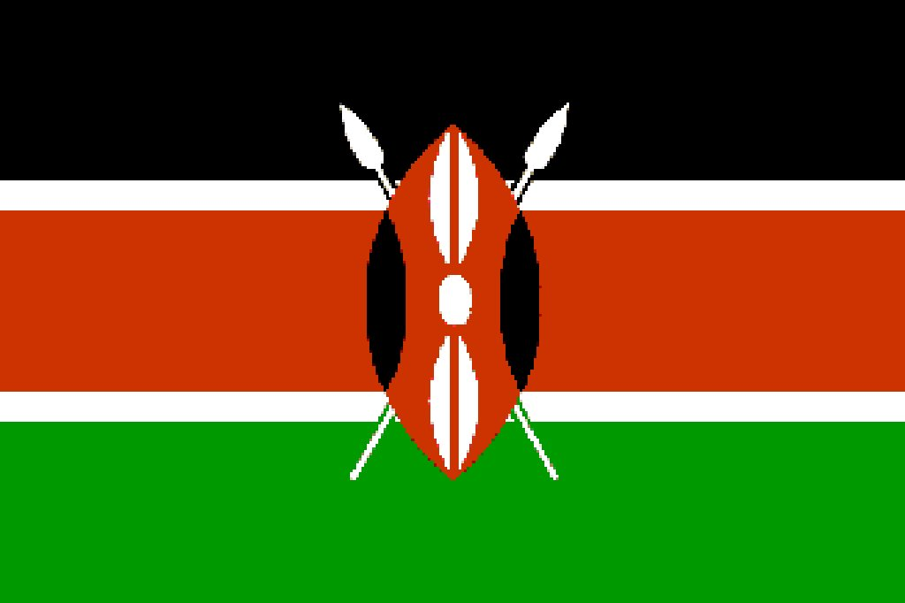
Kenyan Flag: Green for the land, black for the people, red for the blood spilled for freedom.

The Republic of Kenya is in East Africa lying along the Indian Ocean, at the equator.
It is bordered by Ethiopia (north), Somalia (northeast), Tanzania (south), Uganda plus Lake Victoria (west), and Sudan (northwest).

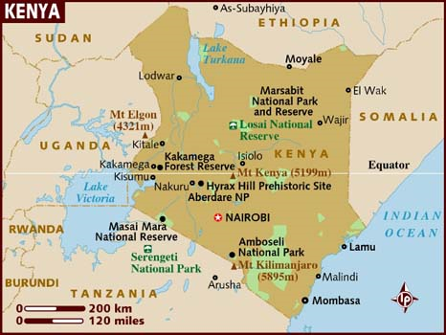
Capital city: Nairobi (meaning place of cool waters)
Size: Kenya spans an area about 85% the size of France or Texas.
Population: The population has grown rapidly in recent decades to nearly 38 million. Kenya has numerous wildlife reserves, containing thousands of animal species.
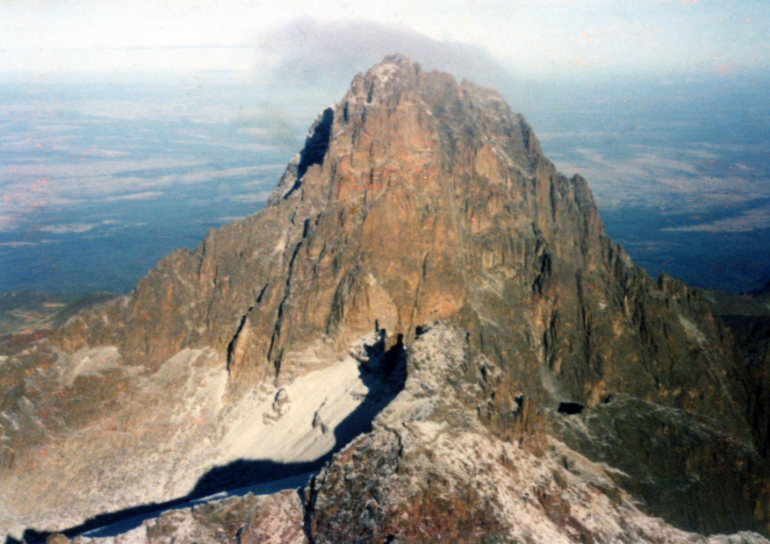
The country is named after Mount Kenya (“Mountain of Whiteness”), a significant landmark and the second among the highest mountain peaks of Africa.

National Motto – Harambe “Let’s all pull together”

Major cities – Mobasa (largest port on the East African coast), Kisumu, Eldoret, and Nakuru

Currency – Kenya Shilling (K Sh) $1US = 85 shillings

Climate – straddles the equator – temperature varies with altitude and terrain. Rift valley averages in the 80s, Nairobi in the 70s. Jan-Feb is dry season.
(Nakuru lies in the southern hemisphere)

Mountains: Mt. Kenya is the highest point at 17,000 feet. (Second highest in Africa) It’s one of the largest freestanding mountains in the world.
Rivers: Athi/Galana and the Tana.
Major Lakes: Victoria, Turkana, Baringo, Naivasha, Magadi, Jipe, Bogoria, Nakuru, and Elementeita.

Economy-
Agriculture- roughly 75% of the population makes living from farming (principal cash crops are tea, horticultural produce, and coffee) agriculture is 16% of the GDP and 50% of export earnings.
Services industry represents 50% of the GDP. Tourism is the largest export earner, industry is 18% of GDP
- 2006 GDP was $500 US/head
- Largest exports: tea, coffee, roses
- Vies with Sri Lanka for second largest tea exporter (India)
- Jua Kali “hot sun” refers to the many small roadside artisans including small groups of women who do traditional handicrafts
- Tourism is huge (and growing) and it is said 1 tourist supports 30 jobs.

Population – 44 million, 42.5% under 14; growth rate at 2.57% (one of the highest in the world); life expectancy – 49 years, 50% of the population below poverty line; 1.2M are infected with HIV. 67% live in rural areas

- High growth rate stemmed from the fact that until recently, a man’s social and economic status was largely determined by the number of children he sired. Polygamy was accepted. Kenyan tradition dictates that once married, a couple must name a child after each of their parents, so they must continue to produce until they have two boys and two girls. Kenyans adore children and women would not consider themselves fulfilled unless they had borne at least one child, whether married or not.
- The decline in growth rate has resulted from the impact of AIDS, and the realization in rural areas that couples cannot support or finance the education of so many children. Emergence of the middle class has many waiting for financial security before starting a family, then opting only to have as many as they can afford to educate at university level.
- There is also a new phenomenon of young professional women opting to have none or one

Ethnic makeup – two major language groups are Bantu (Kikuyu, Meru, Gusil, Embu, Akamba, Luyha, Mijikenda) and Nilotic (Maasai, Turkana, Samburu, Pokot, Luo, Kalenjin. The coastal region is home of the Swahili people.
Tribal breakdown: Kikuyu 22%, Luhya 14%, Luo 13%, Kalenjin 12%, Kamba 11%, Kisii 6%, Meru 6%, other African 15%, non-African (Asian, European, and Arab) 1%.

Religion-
- Protestant 45%,
- Roman Catholic 33%,
- Muslim 10%,
- Indigenous beliefs 10%, other 2%

Language – Official: English, National: Swahili. Most also speak their tribal or mother language

Literacy - 85% of population over 15

Government – independent republic with democratically elected parliament. Its reputation early on has declined due to corruption and lack of investment in infrastructure.

Kenya is viewed as stable, peaceable and balanced and often serves as a mediator on pan-African issues. It also houses 250,000 refugees.

Politics
Current president Uhuru Kenyatta.

Overview: Kenya has maintained remarkable stability despite changes in its political system and crises in neighboring countries. In December 2002, Kenyans held democratic and open elections, most of which were judged free and fair by international observers. The 2002 elections marked an important turning point in Kenya's democratic evolution in that power was transferred peacefully from the Kenya African Union (KANU), which had ruled the country since independence to the National Rainbow Coalition (Narc), a coalition of political parties.
Under the presidency of Mwai Kibaki, the new ruling coalition promised to focus its efforts on generating economic growth, combating corruption, improving education, and rewriting its constitution. A few of these promises have been met. There is free primary education in some areas. In 2007 the government issued a statement declaring that from 2008, secondary education would be heavily subsidized, with the government footing all tuition fees. 2017 is the election year.

Parks & Reserves: There are 56 national parks and reserves and they contain some of the last primordial rain forest and boasts more species of birds than anywhere else in the world
- 80 major animal species from big 5 (Elephant, Lion, Rhino, Leopard, Buffalo) to dik-dik (antelope slightly larger than a rabbit). At least 32 endemic species are endangered
- 1137 species of birds – not uncommon to spot 100 different kinds per day

The “Big 5”: Lions, Leopards, Elephants, Buffalos and Rhinos.
Buffalo - mbogo
Elephant - ndovu/tembo
Leopard - chui
Lion - simba
Rhino - kifaru

Some of the most known Kenyan Animals:

Antelope - pofu/kulungu/pala hala
Baboon - nyani
Bird - ndege
Bushbuck - pongo/paa
Cheetah - duma
Crocodile – mamba
Dik-dik – dikidiki Eland - pofu
Flamingo - heroe
Gazelle - swala/swara/paa/impala
Gerenuk - swala tiga
Giraffe - twiga
Grant’s gazelle - swala granti
Hippopotamus - kiboko
Hyena – fisi
Monkey - tumbili
Oryx - chorea
Ostrich - mbuni
Snake - nyoka
Topi - nyemera/paa
Vervet monkey - tumbili
Vulture - tai/gushu
Warthog - ngiri
Water buffalo - nyati
Waterbuck - kuru
Wildebeest/Gnu - nyumbu/mbogo
Zebra - punda milia (you might even spot the rare brown zebra! Chat is good at spotting them!)
Environmental Issues in Kenya:
- Soil Erosion
- Deforestation is a major problem. With high growth rate, land is needed for crops and fuel for firewood, though 10 million trees have been planted in the last 20 years.
- Water Shortage
- Water pollution increases with use of fertilizers and pesticides. Only 30 percent of rural population has access to safe drinking water.
- Poaching

The People

Maasai – best known, nomadic people whose lifestyle is essentially unchanged for centuries. Daily rhythm of lie revolves around the constant quest for water and grazing for their cattle. They are distinguished by their complex character, impeccable manners, impressive presence and almost mystical love for their cattle. [this is based on the Maasai belief that the sky god, Enkai was once at one with the earth. When the earth and the sky were separated, however, Enkai was forced to send all the world’s cattle into the safekeeping of the Maasai, where as far as the Maasai are concerned, they have remained.] Brave and ruthless warriors they instilled terror in all who came up against them. Henry Stanley advised “ take a thousand men or write your will”. “I hope your cattle are well” is the most common form of Maasai greeting. The milk and blood of the cattle are the preferred diet, while the hides serve as mattresses, salndals, mats and clothing. Cattle also act as marriage bonds, while a complex system of cattle-fines maintains social harmony. The Maasai warrior with his swathe of scarlet shuka (blanket), beaded belt, dagger, intricately plaited hair and one-legged stance remains the most enduring icon of Kenyan tourism.

Kikuyu – largest of the tribes, live near Mt. Kenya, where they came into violent conflict with the European settlers to whom large tracts of land were apportioned by the colonial government. Since land is one of the foundations of Kikuyu social, religious and economic life, it spiraled into war and eventually led to the Mau Mau uprising in the 1950s which ultimately led to the Kenya gaining its independence. As a result, the Kikuyu have always played a dominant role in politics and commerce, including the first president, Jomo Kenyatta. The Kikuyu have successfully adapted to the challenges posed by western culture and technology and their role in modern day business is significant.

Kikuyu Proverb – “There is no rain that does not enrich someone” (It’s an ill wind that blows nobody any good.)

The Swahili or Shirazi – most prominent coastal people, not a tribe, but a product of intermarriages of indigenous Kenyans with the waves of Persian, Portuguese and Omani conquerors. Most are Muslim, but their relaxed way of life is worlds away from Middle Eastern Muslims. They excel in literature, art and architecture, while Swahili craftsmen are known for their beautiful triangular shaped dhows

Swahili Proverb – “Ndovo wawili wakisongana, ziumiazo ni nyika.” (When two elephants jostle, what gets hurt is the grass!)

Asians – Many descended from the indentured servants who chose to stay following the completion of the Railroad. Mostly a self-contained community, nurturing its own culture, it is largely impervious to the African cultural influences.

White community – small in number. Referred to by Kenyans as Muzungu (singlular) or Wazungu (plural) – roughly translates to “European” but can also mean “something strange and startling”. Half live in Nairobi – particularly a suburb referred to as Karen after Karen Blitzen, the author of Out of Africa.

The dispossessed – Colonial policies and attempts to draw the urban population into the economy have led to large-scale migration to the cities. Most arrive penniless and find shelter in overcrowded, unsanitary shantytowns that have risen near business centers. 60% of Nairobi’s population lives in slums.

Brief Summary: Kenya’s evolutionary record goes back 25 million years including homo erectus and homo sapiens. The first conclusive evidence of humans came in the form of fossils found by the Leakey family on the shores of Lake Turkana and in the East African Rift Valley.

There was significant migration from all over Africa followed by Arab and Persian migrants, Portuguese, Omanis. In the mid-1800s, two German missionaries became the first Europeans to venture into the interior. They were followed by British explorers, including Henry Stanley and Dr. David Livingstone, who came in search of the source of the Nile. In 1885, the British began the construction of the Mombasa to Uganda railroad (dubbed the “Lunatic Express”) which was completed in 1901. In 1896, the first British settlers arrived.

In WW1, Europeans had appropriated most Kenyan farmland. One in four of the soldiers and porters conscripted into the African rifles died. In 1920, Kenya became a colony (from a protectorate). After WW2, when the African Rifles again performed bravely, they returned home to find that British soldiers were being awarded land, but native soldiers were not. This ultimately led to the Mau Mau rebellion in the 1950s. While the rebellion was put down, the independence movement gained strength and in 1960 the British Government began to pull out, with independence day being June 1, 1963 and Kenya became a republic on 1964.

Values and Attitudes

For many Kenyans tribal ethnicity is the single most important part of their personal identity. Though many have moved away from tribal customs, speaking the tribal language is a mark of tribal identity. Politically, there is movement away from tribal alignment, though it still exists. There is a code of Corporate Social Responsibility that basically dictates that tribal links should have no bearing on the job market.

Racial discrimination based on color is largely unknown. Many find the pinkness and ungainly gait of white people slightly amusing.

To describe someone as “black” is usual in Kenya. In western Kenya they are called “very black”

Kenya has a strong national identity. Temporary residents are often asked “how long have you stayed here?” (stayed rather than lived). If you’ve been there for over two years, you are often referred to as “almost Kenyan” – this is a compliment.

Kenyans place great emphasis on showing respect to their fellow man. Upon meeting someone, it is customary to shake hands and to inquire after their health and welfare of their family. It relates to the fact that many Kenyans are forced to find work far away from the place of their birth and only travel home once or twice a year. News of children, family, births, etc. is crucial.

Kenya has strong tradition of hospitality and is good at it. If a visitor “enjoys” the Kenyans are delighted.

Kenyans are a hugely gregarious society and a lone Kenyan is unusual. Western love of privacy and seclusion is an anathema, and visitors or residents traveling or living alone are viewed with compassion, while energetic attempts will be made to absorb them into the family or social group. Because of tight spaces and communal living, there is no respect for personal space. Lines, therefore, are generally cheerfully tight-packed and chatty. Until roped-off lines were recently placed in banks, it wasn’t unusual to have several fellow customers interestedly peering over your shoulder.

Everyone must have their say…”Baraza” (a community meeting under the shade of a tree in which everyone is invited to have their say), Kenyans are respecters of your right to speak. They are loath to talk over you, cut in, or otherwise muscle in on your right to a share of the floor. – It works both ways, Kenyan speeches are very long.

“Swahili time” – attitude to time is complex, but essentially patient and relaxed. Concept of punctuality is casual at best. They will often refer to BMT – Black Mans time. Swahili time runs from dawn to dusk to dawn as opposed to noon to midnight to noon. Much is due to the fact that the everyday rigors of life have taught the Kenyans the all important skill of being able to live for the moment, without indulging in too much introspection regarding what has gone on before or what the future may bring.

Faith – no matter the religion, Kenyans are exceptionally devout. Going to church on Sunday is an exuberant event and not to be missed. The bible (or Koran) is the book of choice, knowledge of the scriptures is aspired to, praying is part of everyday life, amplified religious meetings are held in most public areas at lunch time….

The People of Kenya

The Kenyan people are very diverse and include most linguistic and ethnic groups in Africa. About 98% of them are Africans. Because of the tribes, national identity is rather weak, although most governments have tried to create a ‘Kenyan identity’.
Kenyans on the whole are friendly and relaxed people, who enjoy everyday life. They are never too busy to make time for you, and little crowds gather in no time if something extraordinary is happening. Foreigners are interesting to them and white people (‘mzungus’ in Swahili) often draw some sort of (friendly) attention

Family, however, is even more important than tribe in Kenya culture. It’s common for a family to live together with uncles, nieces etc. Family bonds are strong. Although it’s common for a father and mother to leave their children with family and work in another city, this is usually inspired by the wish to support their family better. Daycare doesn’t exist in Kenya although rich families may hire nannies.
Women are often the backbone of village life, as they do the bulk of the work. While women are visible in society, and can get into higher paying jobs, their role in society remains limited and often rigid.

Kenyan men are not as woman-friendly as European or North American men. In Kenya, it is said that men are regarded as the ‘first’ gender. While Kenyans are friendly and relaxed people on the whole, it is not unusual to hear “a womans place is the kitchen” type of arguments espoused by Kenyan men. This is even more the case with men who still live a traditional, tribal life style (which is only true of a minority of all Kenyans). The practice of female genital mutilation is decreasing but still quite widespread.

At the same time it’s true that Kenyan women are visible in society. They are not the types to sit quietly in a corner. They have sometimes pretty high-ranking jobs and some are active in politics, business and the media and entertainment sector. In mid 2007, eighteen of 222 members of the Kenyan parliament were women. Older Kenyan women have traditionally an important role in tribal life, and command respect. Women are often the backbones of villages as they do the bulk of the farming work.

But the December 2007 elections showed that some Kenyan men still have a problem with that. In the weeks before the election, no less than 255 cases of Kenyan men assaulting female political candidates were reported to the police, with no arrests following. Many received threatening or humiliating text messages. One female political candidate, Alice Onduto, was shot to death.
Within Africa, Kenyans enjoy a reputation as hard workers and at 7 o’clock the streets are crowded. However, Kenyans take it easy and have a casual approach to time. Making appointments days in advance, as in North America or Europe, is often useless in Kenya culture. Better call an hour before you want to see somebody, and ask whether he is around (if he is, he will drop his work). Of course, the more important an official is, the longer you’ll have to wait outside his office, even if he is inside doing nothing. If somebody is 30 or 60 minutes late for an appointment, he is considered to be perfectly in time in Kenya. The first days, you will be annoyed, but pretty soon you’ll come to like to slowness of life and go along with it.

Kenyans like to laugh and quickly offer a smile to people. The British influence is still visible in their politeness, and also in the outer appearance of streets and buildings, signs etc. which look a bit like Britain in the 1960s... A Kenyan will take the time for you if you ask him something. If there is just anything unusual, a crowd will assemble within a minute around you and everybody will offer his opinion on what’s going on. Even foreigners are quickly invited to participate in whatever’s going on. When meeting someone, a Kenyan will greet him extensively. Shaking hands is normal between men when meeting and departing. Women also shake hands with each other, but with men only in more sophisticated circles.
Kenyans naturally touch each other easily, like in Latin culture. Be aware of the fact that the left hand is seen as unhygienic. So use your right hand to pass things to someone, to touch somebody, etcetera. However, this rule is not always followed and just ignore it then. Pointing your finger at someone is seen as rude.
Kenyans dress conservatively. Kenyan men wear shirts and long trousers, often with a blazer or sweater. Women wear long trousers or skirts below the knee. This is even more so at the coast, where the majority are Muslim.

Strong work ethic, thousands of university graduates cannot find jobs. One salary, particularly in tourism will support an entire extended family. There is no social security and the cost of healthcare and education is borne by families. However little there is, is willingly shared. Education is highly valued as a means to “make something of oneself.” It is not unusual to find grown men/women in classes with 8 year olds. It’s not too late to learn and truancy is unknown.

Eating and sharing food is very important (often due to shortage). Someone who is accepting bribes is referred to as “eating” – not sharing. Kenyans prefer to eat in a group at a table under a tree. They don’t understand but will respect your right to eat privately, but should you have something left over, the gesture of sharing is much appreciated. Kenyans rarely waste water or food.

Kenyans love children (watoto). Not wanting children is incomprehensible. Women who will not or cannot have children are pitied or ostracized (in rural areas). Kenyan children are silent – rarely heard to cry, well-behaved, deferential and acquiescent to the desires of their elders. No spoiled Kenyan children. They are expected to contribute and are supported by the group.

Kenyans revere the patriarch. Wishes of the father are universally respected and the grandfather revered. The father figure of the chief is still central and his blessing is required for everything from politically appointment to cutting down a tree.

Kenyan women are strong in character (referred to as “kali mamas”) and respected in their communities, they bow to the dictates of their menfolk. Men revere their mothers, respect their wives and understand the risks of cheating on them, but often do. The women view that if a man strays it is due to the lures of the women and it is her duty to lure him back into the marital fold with smiles, good food and attention to their needs. Sexual harassment is still prevalent. In urban areas, tight jeans, mini-skirts, etc. are accepted, but in rural areas a woman in a mini-skirt could be stoned or striped and thrown into the gutter for her wantonness. Polygamy is not outlawed, but on the decline, and selling your daughter to a rich old man was one of the perks of fatherhood. Disciplining your wife was considered necessary. Domestic violence and abuse of girl children is still a problem.

Kenyans tend to be stylish and immaculate in their dress. If it rains, they will carry their shoes and walk with an umbrella. Most women dress modestly, but city girls wear tight clothes, etc. If you are invited to a wedding or other event, you will complement your host by dressing up. In Muslim areas, women are still veiled. In Asian areas, it’s 50/50. If in Mombasa, Malindi or Lamu, respect the Islam traditions and avoid skimpy clothes in public places – no topless sunbathing!

Bribery is common and accepted as “the way things are”. However, few visitors are directly confronted with it. However it is circumstance dependent. It may be preferable to pay a fee rather than spend 8 hours in a jail cell. However the optimum response to a bribery suggestion is avoidance.

Half of all Kenyans live below the poverty line and it is very visible. Begging is very common. Kenyan charities will tell you it is better to give to the needy through the charities so as not to support the begging mentality.

Crime is high in certain areas and it is dangerous to go out at night

There are about 550,000 AIDS orphans and 78000 children living with HIV/AIDS. Despite education and awareness, men continue to view visiting a prostitute (90% of whom are HIV positive) as a right of the red-blooded male. There is still denial of the AIDS problem and at funerals and in papers the word AIDS is rarely mentioned.

Considerable resentment exists among the rural population living near national parks. They feel the land should be theirs to cultivate and until recently haven’t seen much benefit of tourism.

Land ownership is of extreme importance to Kenyans no matter how small they must have a shamba or small plot of cultivable land.

Religions & Beliefs

Kenya is steeped in myths and folklore. As in other parts of Africa, the human and the spirit worlds are inextricably bound together. People communicate with the gods through the medium of ancestors, deities, or local spirits. Beliefs and rituals are closely connected to the coming of the rains, upon which life depends.

The Maasai Legend of the Sun and Moon
Long ago the sun married the moon but one day they fought and the moon struck the sun on the head. Of course the sun hit back and damaged the moon. When they had finished fighting, the sun was so ashamed of his battered face that he became so dazzlingly bright that humans could not regard him without half closing their eyes. The moon, however, was not in the least bit ashamed and anyone looking at her can clearly see her mouth is cut and one of her eyes is missing.”

Belief in the power of ancestors remains strong. The Luo, for instance, believe in ancestral ghosts.

Many of Kenya’s indigenous religions center on those who can intercede with the spiritual realm, such as “witch doctor”, wizard, soothsayers, diviners, and shamans.

Herbal medicine is highly regarded – not only is it cheaper and more easily obtainable than pharmaceutical, but is believed to be more effective since it treats the ailment in a holistic manner.

Each of Kenya’s ethnic groups has its own version of how the world was created. One of the best know is the Kikuyu story, whose influence remains so strong that most Kenyan families name their girl children after Mumbi (the tribe’s mythological creator) or one of her nine beautiful daughters.

Superstitions: Every tribe has its own. Bees circling the head means news, good or bad, within two days. A dog or a cat crossing one’s path is unlucky.

Christianity is Kenya’s dominant religion. Protestants make up 45 percent of the population, Roman Catholics 33 percent, and African Christian faiths 10 percent.

Music, rhythm, dancing, singing and rejoicing are central to Kenyan religion, which is far more passionate than in Europe.

Islam is about 10 percent of the population, mostly congregated on the coast and in the northeast.

Kenyans have a very relaxed attitude toward punctuality. Arriving a half-hour late is nothing at all. Not arriving at all is not unheard of. Neither should be taken personally.

Kenyans hold both its flag and its national anthem in high regard. Visitors should stand when the flag is being raised or lowered or when the national anthem is playing.

Kenyans consider it gravely insulting to shout at anybody even with words of praise. They respect self-control and quiet but measured speech.

Kenyans have a passion both for having their pictures taken and for taking other people’s pictures. And the arrival of digital photography has intensified this because they can now see the results immediately. Nevertheless, it is courteous to ask people for permission to take their picture, particularly in rural areas where superstition still suggests that the camera is a stealer of souls. A token payment is expected, more as a form of polite appreciation than anything else.

Tipping is not common by Kenyans but has come to be expected by visitors. In a restaurant you may round up the bill if you have had good service. In the tourist sector, a 10% charge is added along with the 16% VAT and 2% catering levy. Many hotels have a staff box and prefer you contribute to that which is split among all the staff.

Proper acknowledgment: Eye contact is important. It is customary to see your fellow man and acknowledge him/her with a smile, gesture or a greeting (such as “jambo” or “Habari”). It is considered impolite not to shake hands upon meeting someone, whether you have met them before or not.

