PRUMC Costa Rica
Mission Team
Handbook
January 2024
Team Leaders:
Josh Miles and Kathleen Goodman

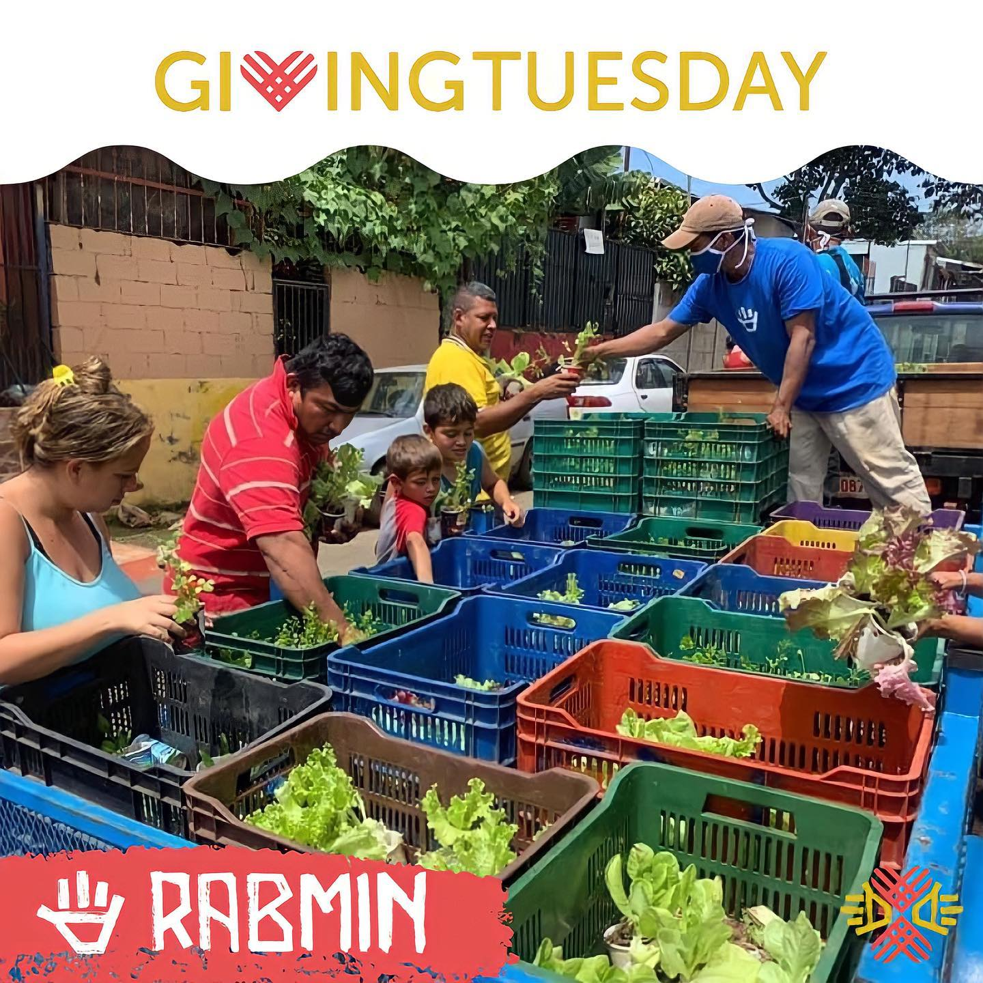

Table of Contents

Flight Information | Page 3
Team Roster | Page 4
General Trip Information | Page 5
Packing List | Page 6
Sample Itinerary | Page 7
Host Missionary Team | Page 8
Frequently Asked Questions | Page 9
Map of Costa Rica | Page 11
Preparing Our Hearts for Service | Page 12
Ten Commandments for Mission Teams | Page 13
Basic Spanish Phrases | Pages 14

Flight Information
Dates of Travel: 1/24/24-1/28/24
From: Atlanta, GA to San Jose, Costa Rica

Airline | Flight # | Date | Departure City | Arrival City | Departure time | Arrival time
Delta | 1937 | 1/24/24 | Atlanta, Ga (ATL) | San Jose | 9:45am | 12:53pm
Delta | 1756 | 1/28/24 | Costa Rica City (GUA) | Atlanta | 2:23pm | 7:34pm

Those going on extension will return on 1/30/24 – same flight

Team Roster
Joseph | Benken
Becca | Blackman
Lollie | Davis
Kathleen | Goodman
Rebecca | Johnson
Annie | LeSage
Tom | Liddell
Zach | Martin
Haley | McKee
Josh | Miles
Emma | Rohrer
Carsen | Vereen

GENERAL TRIP INFORMATION

Accommodations
Our group will stay at the team house located on a small farm outside of San Jose, CR. Accommodations will be dormitory style, with shared bathroom facilities. There is no A/C but they do have hot water. Wi-fi is accessible at the ministry center, but is not entirely reliable. This is a week to unplug and enjoy spiritual fellowship.

Food
Breakfast and dinner are served Buffet style for the teams at the ministry center. Peanut Butter and Jelly sandwich lunches are packed for job sites. It is not possible for RABMIN to accommodate special dietary needs so please plan to bring food with you if necessary. Families often bring food to supplement offering for hungry or picky teenagers.

Clothing
Please bring conservative, modest clothing to wear while in Costa Rica. Sleeveless shirts/tanks, running shorts will not be appropriate outside the ministry center. Lightweight pants are best to protect from the sun, but shorts are fine too. Days are warm, but evenings are cooler and breezier so bring layers.

House Rules per RABMIN: .
1)No tobacco, Alcohol, E-cigarettes or vapes while on a trip with Rice and Beans Ministries. If used you will be asked to leave.
2. Shorts must be a minimum of 5 inch inseam. No pajamas or shorts any shorter than a 5” inseam will be allowed outside the dorm.
3. Closed toe shoes must be worn outside the dorm.
4. Do not feed people’s dogs. This is offensive to them. It also can make a dog aggressive.

Safety
Fred has hosted many mission teams; safety is a priority for our in-country travel. We will travel in groups and will not be working in areas with know dangers. No travel is totally risk-free, though, even in the US. You may check the US State Department website (www.travel.state.gov) for any current travel advisories. .

Requirements
- Valid Passport – expiration be past August 28th 2024
- Proof of Primary Health Insurance (Supplemental insurance is purchased through UMVIM)
- Please refer to the CDC website for recommendations regarding other vaccines.

COVID Protocols
- Will follow requirements set by host country. Right now there are no special stipulations for entry or exit.

Trip Cost

Participant Cost $1200
- Includes
  - airfare
  - Room, Board, Transportation
  - Supplemental health insurance
- Excludes
  - Excludes excursions / personal shopping ($50)

PRUMC Project Cost $10,000
- Food supplies and activity supplies (PRUMC provide funds)

Suggested Packing List

Clothing (Please remember to keep your clothing modest – no spaghetti straps or short-shorts)
- 2-3 pair of pants/shorts (recommend: casual pants, capri pants, scrubs, jeans, etc.)
- 4-5 short sleeve shirts
- 2 long sleeve shirts
- 1 sweaters/sweatshirts
- Warm pajamas (no heat and it gets chilly at night)
- Undergarments
- 2 pairs of comfortable shoes for daily use (not ‘flashy’ gym shoes-they may be ruined if painting, cleaning, or construction)
- Work gloves & extra pairs for CRI staff
- Bandana for dust or sun
Other Items
- Soap/shampoo/toiletries (travel sizes are sufficient for one week’s stay)
- Hair ties or something to hold your hair back while working
- Eyeglasses, extra contacts, and sunglasses (Costa Ricans do not typically wear sunglasses so please remove your sunglasses when in conversation)
- Snacks for week for personal use (granola bars, raisins, chocolate, gum, etc. Snacks are going to be important while out each day, so think of things that are easy to pack and will curb your appetite if a meal is delayed)
- Travel umbrella/poncho (especially during rainy season – May-October)
- Earplugs if you are a light sleeper—it can be noisy at night
- Backpack for daily use (use as one of your carry-ons)
- Travel toilet paper/tissues
- Wet wipes/hand sanitizer
- Digital camera
- Spanish/English dictionary/phrase book (not necessary but nice)
- Journal
- Leisure activities: book, cards, etc.
- Passport + photo on phone - Please make sure passport is valid six months past your return date.
- Separate photo ID
- Credit card (Visa or MasterCard is accepted in some markets. American Express and traveler’s checks are not accepted. Call your credit card company before departure to inform them you may be using your credit card out of country.)
- Cash – you shouldn’t need more than $100
- Medications (Prescription & over-the-counter) Keep in original packaging/bottles!
- We recommend that everyone bring their own ‘stomach’ medications – Pepto, Imodium, and ask your doctor to prescribe you Ciprofloxacin in case you get ‘traveler’s diarrhea’, which is possible
- Pain medication for headaches or aches/pains
- If you have allergies, Asthma or other breathing problems, please bring your inhalers/medications
- Do not wear/bring expensive or flashy jewelry. It is recommended not wearing any at all. If you choose to do so, jewelry should be very simple, plain, and inexpensive. Consider leaving wedding rings at home.
Towels and linens will be supplied by the ministry center.
No plug adapter is needed for things like hairdryers, laptops, etc.

SAMPLE Itinerary
Day 1 – Wednesday
Look for RAMBIN sign after getting bags and exit the airport at ground transportation.
Fred Curry or RAMBIN employee will be at airport to assist with travel to retreat center.
2:00 pm Lunch
3:00 pm Orientation
4:00 Prepare Food Bags
5:30 pm Dinner
7:00 pm Team Devotion / games
10:00 pm Bed
11:00 pm Lights Out

Day 2 – Thursday
7:00 am Breakfast
9:00 am Children lessons/activities in community
11:30 am – Lunch for children
1:00 pm – feeding program
5:30 pm Dinner
7:00 pm Team Devotion / games
10:00 pm Bed
11:00 pm Lights Out

Day 3 – Friday
7:00 am - Breakfast
9:00am – 12:00pm – VBS children
2:00pm – work in garden to collect produce for distribution
5:30 pm Dinner
7:00 pm Team Devotion / games
10:00 pm Bed
11:00 pm Lights Out

Day 4 – Saturday
7:00 am Breakfast
9:00am-12:00pm – Community Feeding program and VBS activities
12:00pm-7:00pm – ½ day cultural excursion and dinner
5:30 pm Dinner
7:00 pm Team Devotion / games
10:00 pm Bed
11:00 pm Lights Out

Day 5 – Sunday
Worship
Depart for ATL or excursion

Frequently Asked Questions:

What does the trip involve?
Serving children and families in impoverished rural community near San Jose. Activities will include children’s activities, produce distribution, door to door feeding program.

What is expected of our group?
We ask that everyone keep a positive attitude throughout the planning of the trip as well as the trip itself. Group members need to BE FLEXIBLE and be respectful of Costa Rican culture while in the country. There are several sources in the back of this packet if you wish to learn more about Costa Rica and the culture.

Where will we stay? Rice and Beans Ministry Center houses dorms to accommodate mission teams and is located on a small working farm in the hills near San Jose, Costa Rica

What do I need to wear?
Please bring conservative, modest clothing to wear while in Costa Rica. The people with whom
we will be working are very conservative and we do not want to give them the wrong impression
as we interact with them each day. Ladies, we ask that you not bring cami-style / spaghetti
strap tank tops nor short shorts / running shorts. Please ensure that your clothing is not tight
and/or revealing. Men, please do not bring sleeveless shirts. In addition, please remain clothed
at all times, both on the work sites and on Mimi’s House property. People may get the wrong
impression when they see men without shirts on or women wearing tight, revealing clothing as
they work. We want to be an example for Christ in this community and do not want to hinder
that example in any way.

What about special dietary needs?
At this point, RAMBIN is unable to accommodate special dietary needs. Costa Rica is a third-world
country and it is difficult to obtain gluten-free products and other special dietary foods. In
addition, due to the volume of people we host each day, a special grocery run is not possible.
Please note that we eat peanut butter and jelly sandwiches each day for lunch while working on
the field.

What shots do I need before we leave?
Personal discretion and your doctor’s recommendation should be considered. General
guidelines include each traveler being up to date on tetanus, Hepatitis A, and Hepatitis B
vaccinations. Malaria recommendations vary by province. Please check https://wwwnc.cdc.gov/travel/destinations/traveler/none/costa-rica
for the most up to date recommendations for Costa Rica

What medicine is suggested to bring for personal use?
Cipro - This is a prescription drug you can ask for from your Dr in case you get traveler's
diarrhea. You should ask for 1 500mg pill twice a day for 7 days.
Bandaids and first aid cream or a first aid kit
Cold medicine
Throat Lozenges
Allergy medicine
Tums or Rolaids
Advil/Tylenol
Ducolax
Ammonium
Any personal medication that you take or may need.

Are passports needed?
YES! A valid passport is required when traveling to and from CR. Please check your
passport to ensure it is valid for six months past your return date. You do not need a separate
visa. You will be given a form to register with the US Embassy as you travel.

What will the weather be like while we are there?
CR hosts spring-like temperatures all year round. The climate is tropical, so it is likely to rain at some point of your trip.. It is usually cool in the mornings and evenings (50’s) and warm during the day (70’s and 80s). It can be cooler and breezier than expected due to the elevation. There is no heat or air conditioning. Make sure to
pack layers, warm pajamas, and a rain coat.

MAP OF CR

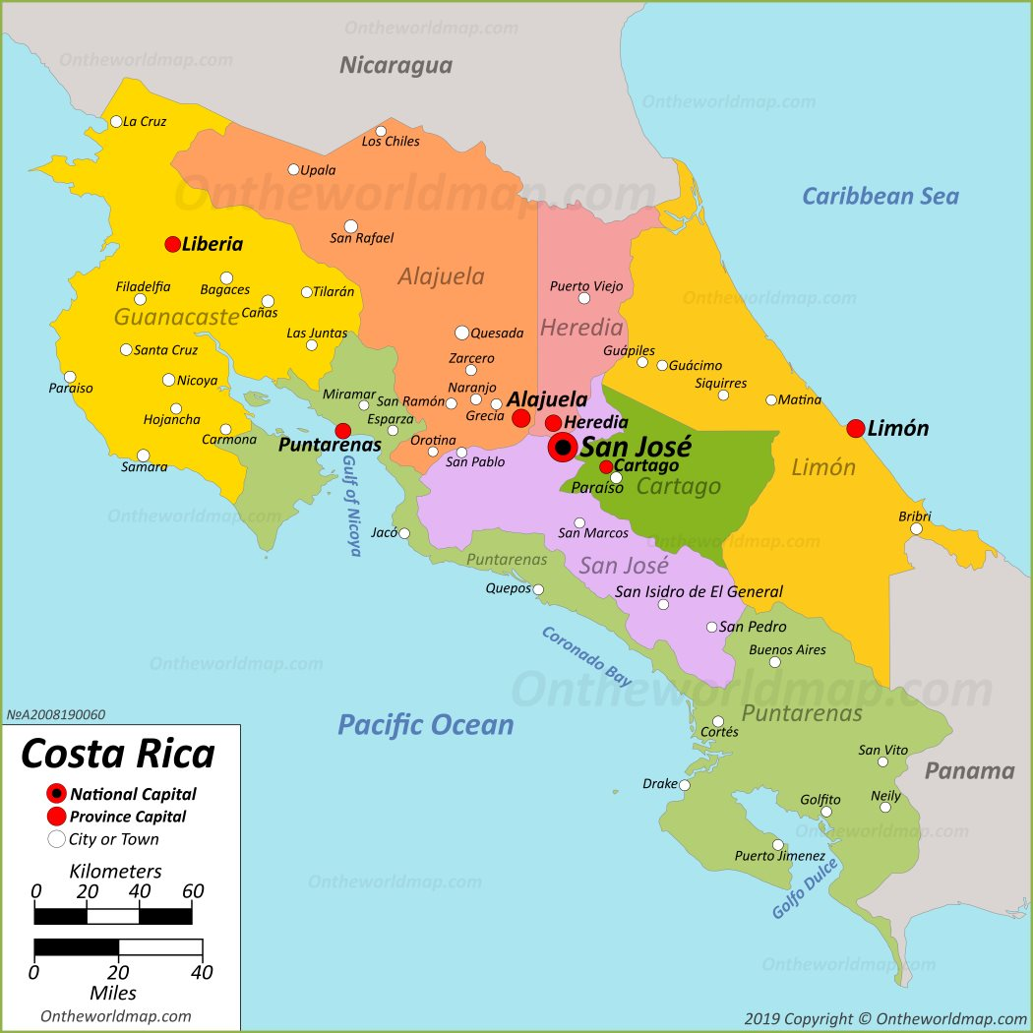

Preparing our Hearts for Service
Be flexible and patient and remember we are there to serve and learn!

- Remember that you are traveling to a third world country. The conveniences of home will not be available. You will be sharing a room with many others, some of our transportation may not be very comfortable and the roads may be worse than you imagined.

- Patience is a fruit of the Spirit, always keep this in mind. Your team leaders have made plans but these plans are ALWAYS subject to change due to current needs, weather or other circumstances. Being flexible and adaptable is the key.

- Keep an open mind as you travel. Don’t go with preconceived ideas of the trip. Trust the fact that God has placed you on this team at this time and is in control, from beginning to end.

- In the kingdom of God, there are no all-stars or celebrities; we are equal in His sight. God loves us all the same. We should treat everyone (our team members, our hosts, those we work with and those we serve) with the same dignity, honor and respect that God has for each one of us.

- Hold 1 John 3:18 closest to your heart “Dear children, let us not love with words or tongue but with actions and in truth”.

Go with a servant’s heart, ready and open to serve in any capacity

Ten Commandments for Mission Teams
(Adapted from the United Methodist Volunteers in Mission Team Leader Handbook)

- Thou shalt not expect to find things as thou hast them at home, for thou hast left home to find things different.
- Thou shalt not take anything too seriously, for a carefree mind is the beginning of a fine work experience
- Thou shalt not let other team members get on your nerves, for thou art ready to have a good time.
- Remember thy documents so that thou knowest where they are at all times. A person without their documents is a person with big problems.
- Remember to take only one half the clothes thou thinkest thou need and twice the money. What thou hath is generally far better than those with whom thou will live and work.
- Remember if we were to stay in one place we would have been created with roots.
- Thou shalt not judge the people of a country by the one individual with whom thou hast had trouble.
- Though shalt not make thyself too obviously American..english.. whatever.. When in Rome do as the Romans.
- Thou shall not worry. They that worrieth hath no pleasure. Few things are ever fatal. Thy team leaders, your team members and the Lord will care for thee.
- Remember that thou art a guest in every land and that those who treat their hosts with respect shall in turn be treated as an honored and much loved guest.
Basic Spanish Phrases

Good morning. | Buenos días. | booEHN-os DEE-as
Good afternoon. | Buenas tardes. | booEHN-as TAR-dehs
Good evening. (greeting) | Buenas noches. | booEHN-as NO-chehs
Hello, my name is John. | Hola, me llamo Juan. | OH-la meh YA-mo Wahn
What is your name? | ¿Cómo se llama usted? | KOH-moh seh YA-mah oos-TEHD
How are you? | ¿Cómo está usted? | KOH-moh ehs-TA oos-TEHD
I am fine. | Estoy bien. | ehs-TOY bee-EHN
Nice to meet you. | Mucho gusto. | MOO-choh GOOS-toh
Goodbye. | Adiós. | ah-dee-OHS
See you later. | Hasta luego. | AHS-ta looEH-go
I am lost. Where is the restroom? | Estoy perdido. ¿Dónde está el baño? | ehs-TOY pehr-DEE-doh. DOHN-deh ehs-TA el BAH-neeo
Excuse me. | Con permiso. OR Perdóname | kohn pehr-MEE-soh OR pehr-DOH-nah-meh
Please. | Por favor. | pohr fah-VOR
Thank you. | Gracías. | gra-SEE-ahs
I'm sorry. | Lo siento. | low see-EHN-to
Bless you. | Salud. | sah-LOOD
You are welcome (it was nothing). | De nada. | deh NA-da
How much does it cost? | ¿Cuánto cuesta? | kooAN-to KWEHS-ta
How many are there? | ¿Cuántos hay? | kooAN-tohs eye
There are many. | Hay muchos. | eye MOO-chohs
Do you want to buy this? | ¿Quiere comprarlo usted? | kee-EHR-eh kohm-PRAR-loh oos-TEHD
What time is it? | ¿Qué hora es? | keh OR-ah ehs
May God bless you? | Que Dios te bendiga
May God bless you (formal) | Que Dios le bendiga
Yes. | Sí. | see
No. | No. | no
I do not understand. | Yo no comprendo. | yoh no kom-PREN-doh
Would you speak slower, please. | Por favor, habla mas despacio. | pohr fah-VOR, AH-blah mahs dehs-PAHS-ee-oh
Who? | ¿Quièn? | kee-EHN
Why? | ¿Por què? | pohr keh

