PRUMC Guatemala
Mission Team
Handbook
December 2024
December 27th – January 3rd

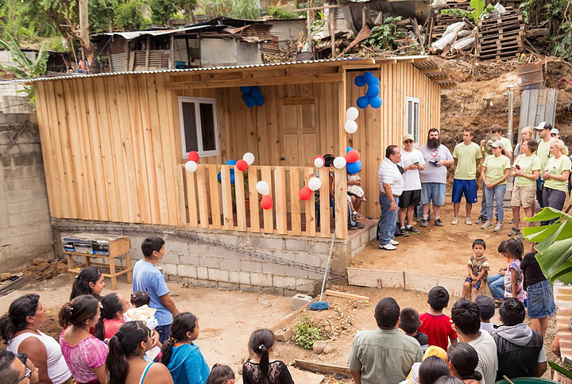

“I’d Like To Teach The World To Sing”

I’d like to build the world a home
And furnish it with love
Grow apple trees and honey bees
And snow white turtle doves

I’d like to teach the world to sing
In perfect harmony
I’d like to hold it in my arms
And keep it company

I’d like to see the world for once
All standing hand in hand
And hear them echo through the hills
For peace throughout the land

That’s the song I hear
Let the world sing today
A song of peace that it goes on
And never goes away

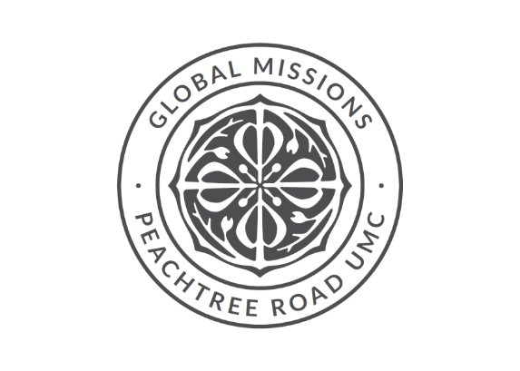

Dear Mission Team Member,

We are called to serve; and you have answered that call. Now what? It can be scary to step outside of your comfort zone to go on a mission trip, but God has equipped you with gifts to share in doing His work in the world. You may think you lack skills or experience to do this type of work, but that is not true. You have been called to share God’s love to make a difference in this world. The only skills required are an open mind and a servant heart; God will take care of the rest.

We hope this handbook will be a useful to fool to prepare you for this journey. It provides logistical details that will hopefully ease any concerns that you may have and allow you to be open to the tremendous impact that this trip may have on your spiritual journey. You will have the opportunity to learn from one another, share stories and witness God’s grace in a way that is not afforded in our daily lives here in Atlanta.

The Peachtree Road UMC congregation and Global Missions thank you for taking this opportunity to build relationships with people from another culture and to work alongside our partners to make an impact in impoverished communities through our efforts to provide clean water, safe shelter and education opportunities for families throughout the world.

With Love and Prayers,

Dawn Hawkins
Director of Global Missions
dawnh@prumc.org

Table of Contents

Flight Information | Page 5
Team Roster | Page 6
Sample Itinerary | Page 7
Purpose & Our Hosts | Page 8
Frequently Asked Questions | Page 9
Packing List | Page 11
Map of Guatemala | Page 12
Preparing Our Hearts for Service | Page 12
Ten Commandments for Mission Teams | Page 13
Basic Spanish Phrases | Pages 14

Flight Information
Dates of Travel: December 27th – January 3rd
From: Atlanta, GA to Guatemala City, Guatemala

Airline | Flight # | Date | Departure City | Arrival City | Departure time | Arrival time
Delta Airlines | 1830 | 12/27/24 | Atlanta, Ga (ATL) | Guatemala City (GUA) | 9:50am | 12:25pm
Delta Airlines | 1830 | 1/3/25 | Guatemala City (GUA) | Atlanta, Ga (ATL) | 1:59pm | 6:233pm

Team Roster
1 | Caroline | Dickey
2 | David | Dickey
3 | Rebecca | Dickey
4 | Thomas | Dickey
5 | Franklin | Glover
6 | Meredith | Glover
7 | Nancy | Glover
8 | Ryan | Glover
9 | Allyson | Kiel
10 | Emerson | Kiel
11 | Jordan | Kiel
12 | William | Kiel
13 | George | Nunn
14 | George | Nunn
15 | Kingsley | Nunn
16 | Sarah | Nunn
17 | Christopher | Revell
18 | Jackson | Revell
19 | Sally | Revell
20 | Sara Kate | Revell
21 | Bobby | Spencer
22 | Kathryn | Spencer
23 | Luke | Spencer
24 | Rob | Spencer
27
28
29
30

SAMPLE Itinerary
December 27th: PRUMC team will arrive TBD
Look for CRI sign after getting bags and exit the airport at ground transportation.
Load on to CRI bus and travel to CRI – orientation if time permits

Day 1 - December 28th:
7am Breakfast
Volunteers make sack lunches for team - provision provided by CRI
8:00 am Load up on bus with sack lunch and depart
9:00 am Santa Maria community intro to families for house builds. Construction begins.
3:30 pm Clean up
4:00 pm Board the bus
5:00 pm Arrive at CRI
5:30 pm Dinner
7:00 pm Team meeting and games
10:00 pm To bed
11:00 pm Lights out

Day 2 - December 29th
8:00 am Breakfast
10:00 am Church Service at CRI
12:00 pm Board bus for Antigua - lunch, historical walk about, shopping
4:00 pm Board busses
5:30 pm Dinner at CRI
Team meeting and game night

Day 3 –December 30th
Same schedule as Day 1

Day 4 – December 31st
Same schedule as Day 1

Day 5 – January 1st
7:00 am Breakfast
No sack lunches needed.
Bus to Walmart - buy food for Community lunch and festival and gifts for each home
12:30 pm Set up for Community Festival
Festival with lunch, jumpies and various activities with Santa Maria community
PRUMC brings activities like face painting, tattoos, crafts and soccer balls

Day 6 –January 2nd
Volunteers make sack lunches for team - provision provided by CRI
8:00 am Load up on bus with sack lunch and depart
9:00 am Santa Maria community home build completion
2:00am Home dedicastions

Day 6 –January 3rd
Return to Atlanta

Purpose
This handbook was written to help you prepare for your journey to Guatemala and to provide a better understanding of what to expect while you are there. We hope that you are excited for the trip ahead! You can be sure that you will be challenged and stretched in new ways. Consider what led you to go on this trip. And what gifts that you can bring while serving.

Our Hosts

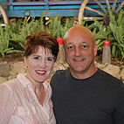
Fontaine & Paula Greene
In 2003, we began our work in Guatemala, while serving as the Lead Pastor of Hope Community Church in Oviedo, Florida. Our eyes were opened to the great needs that existed among the poor in Guatemala, particularly the children. For the next several years, we found ourselves returning to Guatemala more and more often. Eventually, we realized that God was calling us to come to Guatemala as missionaries. In June 2006, we moved our family to Guatemala and began hosting work teams that came to minister in Guatemala. We have been amazed to see how God could use gifts of hospitality to expand His Kingdom and make disciples.
​In 2008, we founded Catalyst Resources International, a registered 501(c)3 organization. As Directors of CRI, we seek to partner in Guatemala with pastors and other Christian organizations in an effort to meet the physical and spiritual needs of the people. Through partnership and shared resources we see disciples being made and the process of multiplication taking place. Our role over the years has been to be used as a catalyst to connect resources to those in need. We anticipate and trust that God will continue to use us in this capacity to impact the world for His Kingdom.

Frequently Asked Questions:

What does the trip involve?
Your group will travel to Guatemala City and stay with Fontaine and Paula Greene at their home in San Cristobal. The Greene family lives at a ministry center that includes five team houses. They utilize your skills and expertise as well as your passions and desires in order to serve those in need.

What is expected of our group?
We ask that everyone keep a positive attitude throughout the planning of the trip as well as the trip itself. Group members need to BE FLEXIBLE and be respectful of Guatemalan culture while in the country. There are several sources in the back of this packet if you wish to learn more about Guatemala and the culture.

Where will we stay?
Your group will stay at the team house located at the ministry center operated by the Greene family. The name of the ministry is Catalyst Resources International. The property is gated and is also located in a gated neighborhood. Employees of CRI are completely trustworthy. 23 Calle 3-63 Lo De Coy Zona 1 Mixco, Guatemala 01057

What do I need to wear?
Please bring conservative, modest clothing to wear while in Guatemala. The people with whom
we will be working are very conservative and we do not want to give them the wrong impression
as we interact with them each day. Ladies, we ask that you not bring cami-style / spaghetti
strap tank tops nor short shorts / running shorts. Please ensure that your clothing is not tight
and/or revealing. Men, please do not bring sleeveless shirts. In addition, please remain clothed
at all times, both on the work sites and on Mimi’s House property. People may get the wrong
impression when they see men without shirts on or women wearing tight, revealing clothing as
they work. We want to be an example for Christ in this community and do not want to hinder
that example in any way.

What about special dietary needs?
At this point, CRI is unable to accommodate special dietary needs. Guatemala is a third-world
country and it is difficult to obtain gluten-free products and other special dietary foods. In
addition, due to the volume of people we host each day, a special grocery run is not possible.
Please note that we eat peanut butter and jelly sandwiches each day for lunch while working on
the field. When planning to come and serve with CRI, you would need to bring all food with you
for your trip (Note: CRI is unable to discount the daily room and board rate due to dietary
restrictions). If you have a concern, please notify your team leader or email us at
info@catalystresources.net prior to your trip.

Will I be safe?
CRI is experienced at hosting mission groups and we do our best to make wise choices for your
in-country travel. We will travel in groups and stay away from areas of known dangers. No
travel is totally risk-free, though, even in the US. You may check the US State Department
website (www.travel.state.gov) for any current travel advisories. There is generally a warning
from the US government to use caution during travel.

What shots do I need before we leave?
Personal discretion and your doctor’s recommendation should be considered. General
guidelines include each traveler being up to date on tetanus, Hepatitis A, and Hepatitis B
vaccinations. Please check http://wwwnc.cdc.gov/travel/destinations/traveler/none/guatemala
for the most up to date recommendation and if you are working in areas outside of Guatemala
City.

What medicine is suggested to bring for personal use?
Cipro - This is a prescription drug you can ask for from your Dr in case you get traveler's
diarrhea. You should ask for 1 500mg pill twice a day for 7 days.
Bandaids and first aid cream or a first aid kit
Cold medicine
Throat Lozenges
Allergy medicine
Tums or Rolaids
Advil/Tylenol
Ducolax
Ammonium
Any personal medication that you take or may need.

Are passports needed?
YES! A valid passport is required when traveling to and from Guatemala. Please check your
passport to ensure it is valid through the ending date of your trip. You do not need a separate
visa. You will be given a form to register with the US Embassy as you travel.

What will the weather be like while we are there?
Guatemala hosts spring-like temperatures all year round. May-October is the rainy season in
Guatemala, so it is likely to rain if your trip is scheduled in those months. It is usually cool in the
mornings and evenings (50’s) and warm during the day (70’s and 80s). It can be cooler and
breezier than expected due to the elevation. There is no heat or air conditioning. Make sure to
pack layers, warm pajamas, and a rain coat.

Suggested Packing List

Clothing (Please remember to keep your clothing modest – no spaghetti straps or short-shorts)
- 3-4 pair of pants/shorts (recommend: casual pants, capri pants, scrubs, jeans, etc.)
- 6 - 8 short sleeve shirts
- 2 long sleeve shirts
- 1 - 2 sweaters/sweatshirts
- Warm pajamas (no heat and it gets chilly at night)
- Undergarments
- 2 pairs of comfortable shoes for daily use (not ‘flashy’ gym shoes-they may be ruined if painting, cleaning, or construction)
- Work gloves & extra pairs for CRI staff
Other Items
- Soap/shampoo/toiletries (travel sizes are sufficient for one week’s stay)
- Hair ties or something to hold your hair back while working
- Eyeglasses, extra contacts, and sunglasses (Guatemalans do not typically wear sunglasses so please remove your sunglasses when in conversation)
- Snacks for week for personal use (granola bars, raisins, chocolate, gum, etc. Snacks are going to be important while out each day, so think of things that are easy to pack and will curb your appetite if a meal is delayed)
- Travel umbrella/poncho (especially during rainy season – May-October)
- Earplugs if you are a light sleeper—it can be noisy at night
- Backpack for daily use (use as one of your carry-ons)
- Travel toilet paper/tissues
- Wet wipes/hand sanitizer
- Digital camera
- Spanish/English dictionary/phrase book (not necessary but nice)
- Journal
- Leisure activities: book, cards, etc.
- Passport and two copies (pack in separate bags) Please make sure passport is valid through the ending date of your trip!
- Separate photo ID and two copies (pack with passport copies)
- Credit card (Visa or MasterCard is accepted in some markets. American Express and traveler’s checks are not accepted. Call your credit card company before departure to inform them you may be using your credit card in Guatemala and the appropriate dates.)
- Cash (can get Quetzals (local currency) at Guatemala City airport; have US SINGLES for tips if necessary. We will make a trip to the ATM in order to get money out for shopping purposes.
- Medications (Prescription & over-the-counter) Keep in original packaging/bottles!
- We recommend that everyone bring their own ‘stomach’ medications – Pepto, Imodium, and ask your doctor to prescribe you Ciprofloxacin in case you get ‘traveler’s diarrhea’, which is possible
- Pain medication for headaches or aches/pains
- If you have allergies, Asthma or other breathing problems, please bring your inhalers/medications and be aware that pollution in Guatemala is high.
- Do not wear/bring expensive or flashy jewelry. It is recommended not wearing any at all. If you choose to do so, jewelry should be very simple, plain, and inexpensive. Consider leaving wedding rings at home.
Towels and linens will be supplied by the ministry center.
No plug adapter is needed for things like hairdryers, laptops, etc.

Remember our days will consist of work projects, so bring items which can be ruined.

MAP OF GUATEMALA

Suggested Reading Materials

- Culture Smart! Guatemala: A Quick Guide to Customs & Etiquette – An excellent book to learn a general overview of the country.
- Guatemala – Lonely Planet (www.lonelyplanet.com)
- Paradise in Ashes – Beatriz Manz
- Guatemalan Journey – Stephen Connely Benz 1996
- To the Mountain and Back – Jody Glittenberg 1994
- I, Rogoberta Menchu – Edited by Elisabeth Burgos-Debray
- The Heart of the Sky, Travels Among the Maya – Peter Canby
- National Geographic Magazine, Into the Mayan Underworld – November 2004, page 36
- Smithsonian Magazine, Beguiling Tikal, Mysteries of the Ancient Maya – July 2004, page 49

Preparing our Hearts for Service
Be flexible and patient and remember we are there to serve and learn!

- Remember that you are traveling to a third world country. The conveniences of home will not be available. You will be sharing a room with many others, some of our transportation may not be very comfortable and the roads may be worse than you imagined.

- Patience is a fruit of the Spirit, always keep this in mind. Your team leaders have made plans but these plans are ALWAYS subject to change due to current needs, weather or other circumstances. Being flexible and adaptable is the key.

- Keep an open mind as you travel. Don’t go with preconceived ideas of the trip. Trust the fact that God has placed you on this team at this time and is in control, from beginning to end.

- In the kingdom of God, there are no all-stars or celebrities; we are equal in His sight. God loves us all the same. We should treat everyone (our team members, our hosts, those we work with and those we serve) with the same dignity, honor and respect that God has for each one of us.

- Hold 1 John 3:18 closest to your heart “Dear children, let us not love with words or tongue but with actions and in truth”.

Go with a servant’s heart, ready and open to serve in any capacity

Ten Commandments for Mission Teams
(Adapted from the United Methodist Volunteers in Mission Team Leader Handbook)

- Thou shalt not expect to find things as thou hast them at home, for thou hast left home to find things different.
- Thou shalt not take anything too seriously, for a carefree mind is the beginning of a fine work experience
- Thou shalt not let other team members get on your nerves, for thou art ready to have a good time.
- Remember thy documents so that thou knowest where they are at all times. A person without their documents is a person with big problems.
- Remember to take only one half the clothes thou thinkest thou need and twice the money. What thou hath is generally far better than those with whom thou will live and work.
- Remember if we were to stay in one place we would have been created with roots.
- Thou shalt not judge the people of a country by the one individual with whom thou hast had trouble.
- Though shalt not make thyself too obviously American..english.. whatever.. When in Rome do as the Romans.
- Thou shall not worry. They that worrieth hath no pleasure. Few things are ever fatal. Thy team leaders, your team members and the Lord will care for thee.
- Remember that thou art a guest in every land and that those who treat their hosts with respect shall in turn be treated as an honored and much loved guest.
Basic Spanish Phrases

Good morning. | Buenos días. | booEHN-os DEE-as
Good afternoon. | Buenas tardes. | booEHN-as TAR-dehs
Good evening. (greeting) | Buenas noches. | booEHN-as NO-chehs
Hello, my name is John. | Hola, me llamo Juan. | OH-la meh YA-mo Wahn
What is your name? | ¿Cómo se llama usted? | KOH-moh seh YA-mah oos-TEHD
How are you? | ¿Cómo está usted? | KOH-moh ehs-TA oos-TEHD
I am fine. | Estoy bien. | ehs-TOY bee-EHN
Nice to meet you. | Mucho gusto. | MOO-choh GOOS-toh
Goodbye. | Adiós. | ah-dee-OHS
See you later. | Hasta luego. | AHS-ta looEH-go
I am lost. Where is the restroom? | Estoy perdido. ¿Dónde está el baño? | ehs-TOY pehr-DEE-doh. DOHN-deh ehs-TA el BAH-neeo
Excuse me. | Con permiso. OR Perdóname | kohn pehr-MEE-soh OR pehr-DOH-nah-meh
Please. | Por favor. | pohr fah-VOR
Thank you. | Gracías. | gra-SEE-ahs
I'm sorry. | Lo siento. | low see-EHN-to
Bless you. | Salud. | sah-LOOD
You are welcome (it was nothing). | De nada. | deh NA-da
How much does it cost? | ¿Cuánto cuesta? | kooAN-to KWEHS-ta
How many are there? | ¿Cuántos hay? | kooAN-tohs eye
There are many. | Hay muchos. | eye MOO-chohs
Do you want to buy this? | ¿Quiere comprarlo usted? | kee-EHR-eh kohm-PRAR-loh oos-TEHD
What time is it? | ¿Qué hora es? | keh OR-ah ehs
May God bless you? | Que Dios te bendiga
May God bless you (formal) | Que Dios le bendiga
Yes. | Sí. | see
No. | No. | no
I do not understand. | Yo no comprendo. | yoh no kom-PREN-doh
Would you speak slower, please. | Por favor, habla mas despacio. | pohr fah-VOR, AH-blah mahs dehs-PAHS-ee-oh
Who? | ¿Quièn? | kee-EHN
Why? | ¿Por què? | pohr keh

